FAX

From: Gold Medal Injury Law
Subject: Letter of Protection
Referral Status: Client Not Yet Scheduled

***PLEASE RETAIN THIS DOCUMENT***

DO NOT DISCARD IF CLIENT PROFILE DOES NOT CURRENTLY EXIST.

Letter of Protection is being sent in anticipation of client being scheduled a at a later date.

The Center for Diagnostic Imaging
An Affiliate of Radiology Consultants of Washington
PO BOX 1450 NW 6035
Minneapolis, MN 55485-6035
(952) 542-8553
(800) 634-4064

ASSIGNMENT OF BENEFITS ATTORNEY'S LIEN

Account number -----

This is to acknowledge I, {{name}} of Washington have
received medical services from the Center for Diagnostic Imaging (Radiology Consultants of Washington). These services were obtained in connection to an injury that occurred on or about {{ incidentDate | longDate }}.

I authorize CDI to furnish my attorney/insurance company(s) with any information contained in my medical records.

In the event of a favorable award or settlement, I hereby authorize and direct my attorney to withhold funds from my settlement and pay directly to CDI any balance due on my account.

I understand that in the event of an unfavorable award or settlement, I will be fully responsible for payment of my outstanding bill.

{{TODAY_LONG}}

Patient's signature
(or responsible party)
Date

I, the undersigned attorney, representing the above patient in regards to the injury date indicated, do hereby acknowledge receipt of the above attorney's lien and agree to honor its terms.

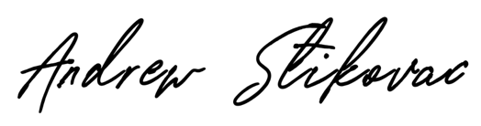

{{TODAY_LONG}}

Attorney's signature Date

Andrew Stikovac
____________________________________

Attorney's Printed Name

